SOFTWARE
REQUIREMENT SPECIFICATION

CSBEES::Online Notes Sharing Application

Project Overview

This project is developed to share class notes online with the world. Community participation is the focus of this project and is dependent on active role of the community to maintain and upload notes and vote them.

The end user gains reputation in the community for contributing in CSBees.

This project can be used as a component that can be used by any school/college on there web site. This project can also be run on the intranet of any school/college.

It facilitates on sharing class notes from colleagues as each school/college has a unique set of lecturers and students who know each other and trust each other. So reading from the notes of someone you know is always good.

Following are the main modules of the project:

- Registration/Login
- Uploading Notes
- Downloading Notes
- Voting on Notes
- Subscribing to Tags
- Creating new Tags
- Posting on Facebook about new Events

- Registration/Login
  - Login Link
  - Login Using Facebook Account
  - Details are returned by Facebook
  - If user is not already enrolled in database, make a new entry and welcome him
- Uploading Notes
  - Uploading Form
  - Server side validation and adding up
  - Display in available notes list
- Downloading Notes
  - Accessing notes list
  - Choosing a note
  - Downloadin the notes file
- Voting on Notes
  - Sending the request to server
  - Altering the votes (positive or negative)
- Subscribing to Tags
  - User chooses tags
  - Notes under those tags are shown to the user
- Creating new tags
  - Display new tags creation form
  - If tag doesn’t exist, create it.
- Posting on Facebook about new Events
  - If a new user signs up or a new note is uploaded, then it should be posted on Facebook
  - Used facebook-php-sdk.
Project Objectives
The objectives of the project are as follows:

- Sharing of class notes and other material by students of the college.
- Encouraging participation in community development.
- Providing an online backup for a user’s notes in a very organized and searchable format
- Rating of user notes.
- Reducing paper work.
- Enabling cross college/school/institutional study process.
- Saving time and money.
- Enabling quality notes access to economically deprived learners.
Project Architecture

Data
Base
Web Server
Middle
Ware
Components
& Business Logic
Apache

Response
Response
Request
Response
- .PHP
Request
Request
Response
Request
Client

- Html
- JavaScript
- [JQuery]
- [AJAX]
- CSS
- [JSON]

- MySQL Server

Web Architecture
System Design

Database Schema

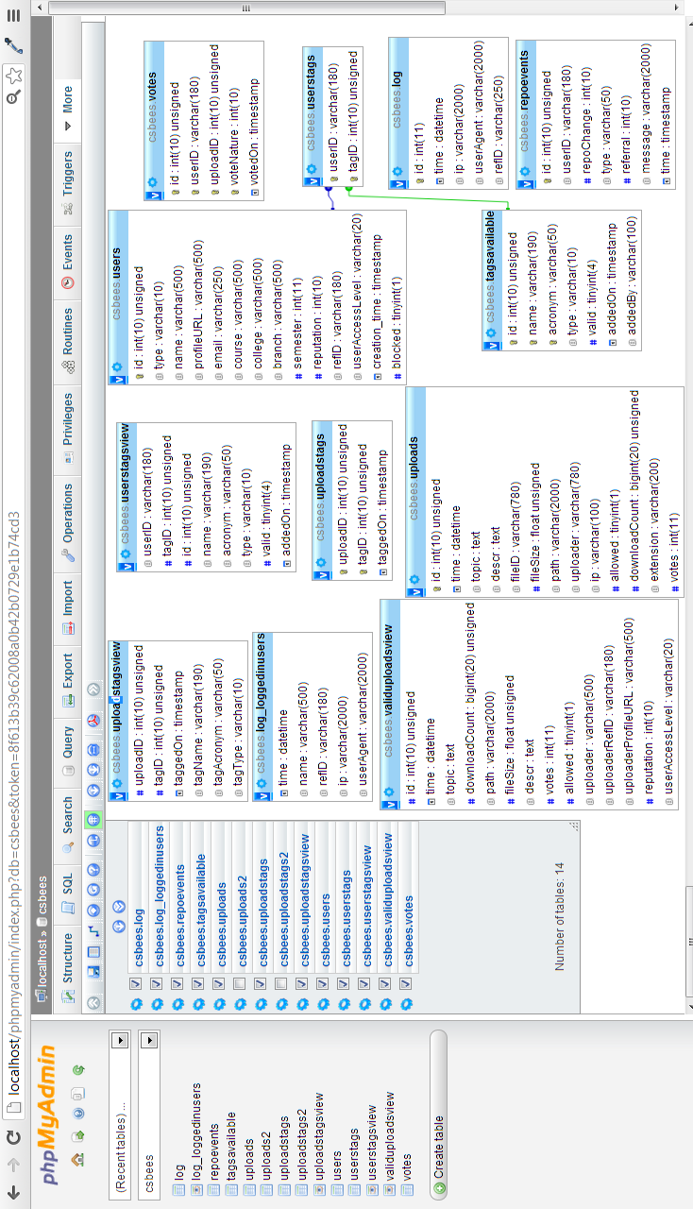
Using CSBees

CSBees can be used by anybody after installation. But to make it usable, we need to create some tags and upload notes in it.

Each note is associated with atleast one tag or many tags.

A tag is defined as either a subject, or a popular topic or a college/university.

No login is required to browse and download notes. But in order to rate or upload notes or to create a new tag and have a personalized experience, the user needs to login using his/her Facebook account.

Overview of Process:
- User opens CSBees in his browser, via http://localhost/csbees/
- Clicks on “fb.Login” button on home page.
- User is redirected to facebook where he enters his//her credentials of facebook.
- Facebook checks users authenticity.
- Facebook displays a dialogue box where our app CSBEES::NEURALS requests for user permissions (email, publish_stream, share_item).
- If the user allows the app, he is redirected back to CSBees’ homepage with status as logged in.
- Otherwise, he is sent back to login page of CSBees and asked to relogin and allow the app.
- If the user is logged in, options to upload notes and edit profile, etc are enabled.
- Incase user goes to uploads page, an option of uploading a new note, creating a new tag is shown.
- If the user goes to profile’s page, he/she can edit his/her nick name. And subscribe to a set of favourite tags.
- If a new note is uploaded under the user’s subscribed tag by anybody, the user can see that note in his “home” page.
- In “My Uploads” page, all the notes uploaded by user are shown.
- In “All Notes” page, all the available notes on the page are shown in chronological order.
- A search bar is provided with natural language searching capability in the bar. User can enter keywords to get matching notes if available. Search looks into topic and description of a note.
- If a note is upvoted by a user, the uploader’s reputation is increased by two points. In case of downvote, the reputation is decreased by 1 point.
- As note’s number of downloads and upvotes/downvotes are shown against it. This helps a user to determine if a note is of good quality or not.

Description of Modules
- Home

After a user is logged in, he/she may visit the home page using top navigation bar. Home page contains the list of those notes which have been uploaded under a tag to which the user has subscribed.
The list is in reverse chronological order, recent most note is displayed at the top.

- Upload Notes

New Notes Form:
This is the interface for uploading a new note.
Title: is the title which is shown as the heading of the note. It should be short and to the point.
Description: is the description of the note. It contains a short write up of the contents of the notes being uploaded and credits, if any.
File: this button is used to navigate and choose the notes file which is to be uploaded.
Tags: These are the short categorizers which help other users to identify the relevance of the note, its domain and category. User starts typing and matching tags are shown below so that the user may choose one of them. Multiple tags are preferable for a note. This way it becomes accessible to many users having interest into that type of notes.

New Tags Form:
Tag’s Full Name: It is the full name of the university, or college or subject, etc.
Tag’s Short Name: It is the acronym of the tag which is displayed to the user
Tag’s Category: It is either a college/university, subject or a popular topic. If the user creates a tag for which whether the acronym or the full name already exists in the database, It is shown to the user before creating new tag itself
The user is first checked if he is logged in or not. If not, he is sent to the login page.

Now, when a user uploads a new note on the server, all the details are properly escaped so as to avoid any SQL injections. The submitted notes file is also verified for invalid extension. If all things are ok, the file is renamed and moved to “uploads folder” and an entry with all the given details are made into the database. The file becomes available to all users as soon as it is uploaded and verified by the system.

- My Uploads

This is the interface for showing those notes which a user has uploaded. It selects all those notes from the database where the uploader is the current user logged in and displays it.
- All Notes

This is the interface for showing all the notes available on the server. It selects all the notes which are present in validUploadsView in the database.

- Profile

This interface has two tabs. One is for selecting a name and other for subscribing to available tags.

A user can choose any nickname not choosen by anybody else. It will be shown against his/her uploads.
A user can choose as many tags as he/she wants to be displayed in his home page. These tags’ id are stored against a user’s user id in “usersTags” table and fetched via “usersTagsView”.
Tools and platform
Software:

- Operating System: OS Independent as long as below requirements are met.
- GUI internet browser ( Like Google Chrome or Firefox)
- Text Editor (Vim)
- PHP 5.3 engine
- Apache Web Server 2.4
- MySQL Server 5.5
- PHPMyAdmin 3.5

Programming Languages:

PHP, HTML, JavaScript
Data Exchange Format: Plan text, JSON, XML

Hardware:

Minimum Hardware Requirement that can support PHP5, APACHE2, MYSQL Server and PHPMyAdmin

1GHz Processor
128 MB RAM

Server Side Runtime Requirement:

- PHP Engine 5.3
- Apache Web Server 2.4
- MySQL Server 5.5

Client Side Requirements:

GUI internet browser

Database:

MySQL 5.5

Important Details:

- Please check integration testing.doc for a list of fixed and known bugs

- Please Read User Manual for further information on installation and operations.

- Please read low level design.doc for reference to what does each file do.

- Please read the code. I have taken the pain to write it to be self-explanatory. For a start, read the above mentioned documents and then start with index.php file.

- This project is still under development.
- The website is online and usable at:
http://csbees.neurals.in
- Entire updated source code is hosted over GITHUB:
https://github.com/hay-wire/csbees
- This open-source project is protected from any type of commercial use by creative commons licence:
http://creativecommons.org/licenses/by-nc-sa/3.0/
- For further support:
please call me at: +91-8826319519
or email me at: Prashant.dwivedi@outlook.com

Acknowledgement

- Numerous websites on the internet which helped me in learning PHP and Web development.
- www.php.net for the awesome language development and support
- www.stackoverflow.com, well you don’t want an introduction to it, do you? ☺
- Special thanks to Neurals (www.neurals.in) for their kind support in hosting process on their server.
- GITHUB (www.github.com) for their awesome platform to host opensource project codes.
- The open source community for developing the awesome free world of tools and internet.
- My cousin Navneet Dwivedi for his ultimate support and contribution in this project.
- My family, parents and friends for their kind support and feedback.
- My teachers for enlightening me ☺

